Phase 4: Automatic Ticket Classification
The second phase is responsible for identifying the issue based on keywords present in the Short Description.
The flow uses If / Else If conditions and Update Record actions to automatically assign the correct category and subcategory.

Activity 1: Wi-Fi Issue Classification
Create an If Condition.
Condition Label: SD is WiFi or Network
Set the conditions:
- Short Description Contains → WiFi
- Short Description Contains → Network
When either keyword is identified, use Update Record.
Set:
- Category: Network
- Subcategory: WiFi
This allows network-related problems to be classified automatically without requiring the student to select the category.
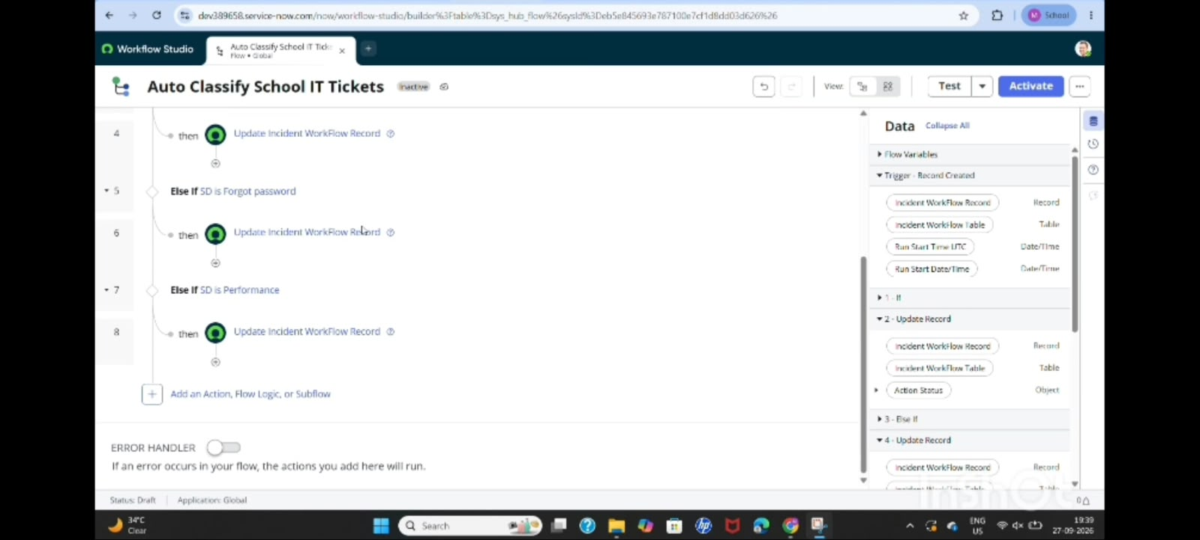

Activity 2: Projector Issue Classification
Select Else If Condition.
Condition Label: SD is Projector or Hardware
Condition:
- Short Description Contains → Projector
Then select Update Record.
Set:
- Category: Hardware
- Subcategory: Projector
This automatically identifies projector-related hardware issues.

Activity 3: Password/Login Issue Classification
Create another Else If Condition.
Condition Label: SD is Forgot Password
Conditions can include:
- Short Description Contains → Password
- Short Description Contains → Login
- Short Description Contains → Forgot Password
Then use Update Record.
Set:
- Category: Access
- Subcategory: Forgot Password
This helps automatically classify problems related to account access, passwords, and login issues.

Activity 4: Slow Computer Classification
Create another Else If Condition.
Condition Label: SD is Performance
Conditions:
- Short Description Contains → Slow
- Short Description Contains → Hanging
- Short Description Contains → Slow Computer
Then select Update Record.
Set:
- Category: Performance
- Subcategory: Slow Computer
This automatically identifies computer performance-related issues.
Classification Summary
Keyword in Short Description | Category | Subcategory
WiFi / Network | Network | WiFi
Projector | Hardware | Projector
Password / Login | Access | Forgot Password
Slow / Hanging | Performance | Slow Computer
This phase ensures that tickets are classified consistently and reduces the possibility of incorrect manual categorization.

